Working with Page-Level Newspaper Issues

ProQuest newspaper products are available at either an article or a page level. Here are some tips for working with newspapers that are scanned in at the page level, using ProQuest Historical Newspapers: The Detroit Free Press as an example:

- From the Basic Search, we can see that the article-level and page-level scans for this particular newspaper are listed separately. To see the difference, hover over the little “i” icon. Page-level scans will be identified as newspaper pages.
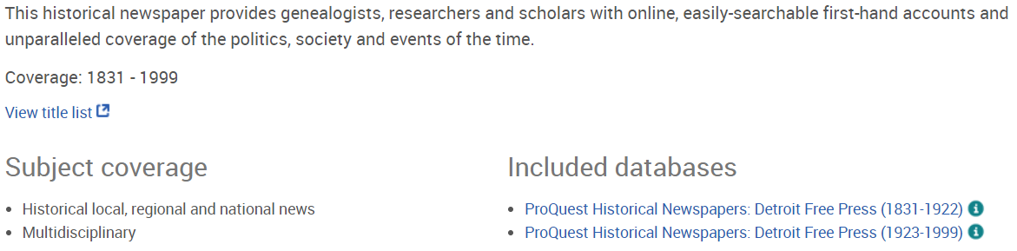

- From the Publications search, we can see if the paper is split between page- and article-level scans and/or if its name has changed over the course of its publication run. Here we see that instead of Publications the Recent Newspapers for Detroit Free Press says Browse Issues, because the more recent the paper, the less likely the name has changed.

- Example: If we want to look at the paper from August 24, 1981, we will click the run that includes 1923-1999. If you click More publication information we can see very specific information about any exceptions or gaps in coverage.
  - Issues may be missing due to issues such as scanning problems or original papers being missing 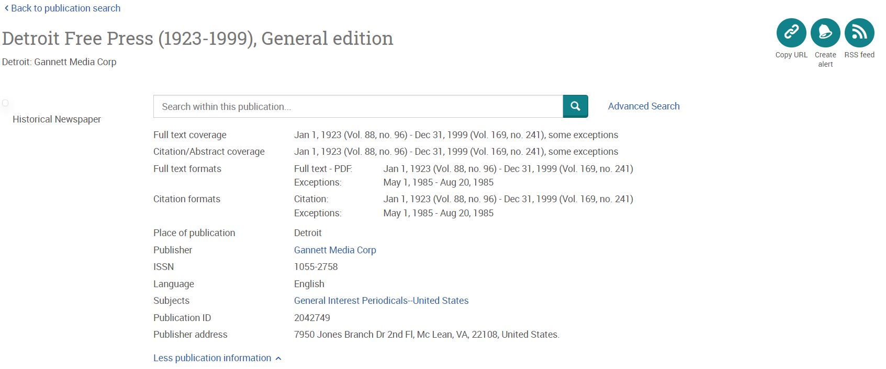

- The issue contents are listed by page, as in page 1 of 58. Also, the only link we see is to the Full text. There is no Details page for these entries because there is no extra indexing applied to these pages 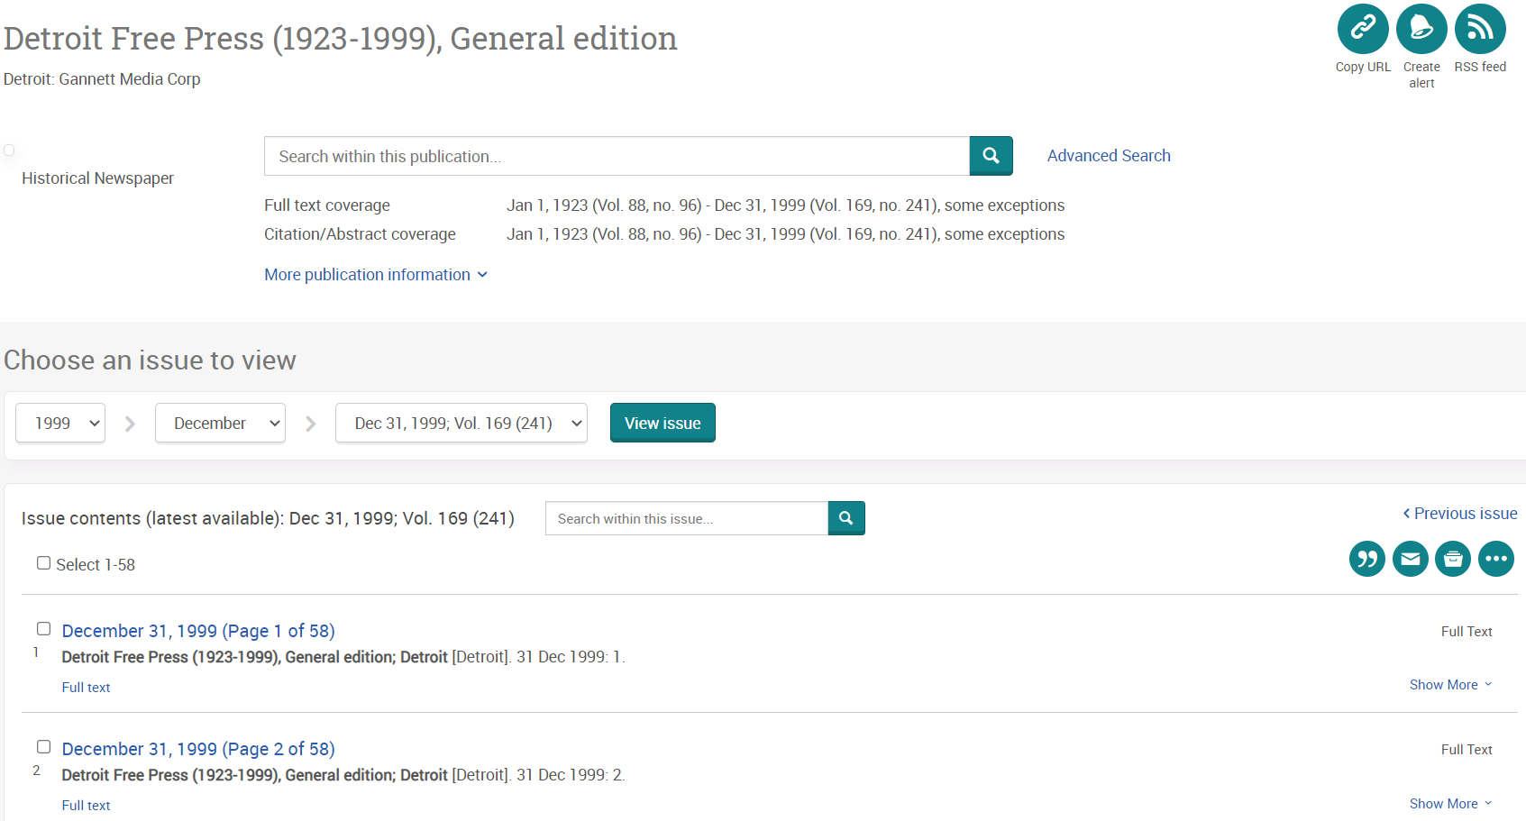

- All page-level newspapers are normal PDFs, so we can scroll down on the page or zoom in as needed. We still have access to the usual ProQuest Platform options for downloading, citing, printing, etc.

- At the bottom of each page we see a “film” strip with thumbnail images of the pages of the paper, similar to the look of a microfilm machine.

Home - News @ ProQuest - LibGuides at ProQuest

